Prefix Sum Technique: With Examples, Code and Visualization
In DSA and competitive programming, prefix sum (also called cumulative sum) is a simple yet remarkably useful technique.
A prefix sum is essentially a sequence of running totals. For an array, the prefix sum at any position is the sum of all elements up to that position. This basic concept allows us to solve complex problems with impressive efficiency.
‍
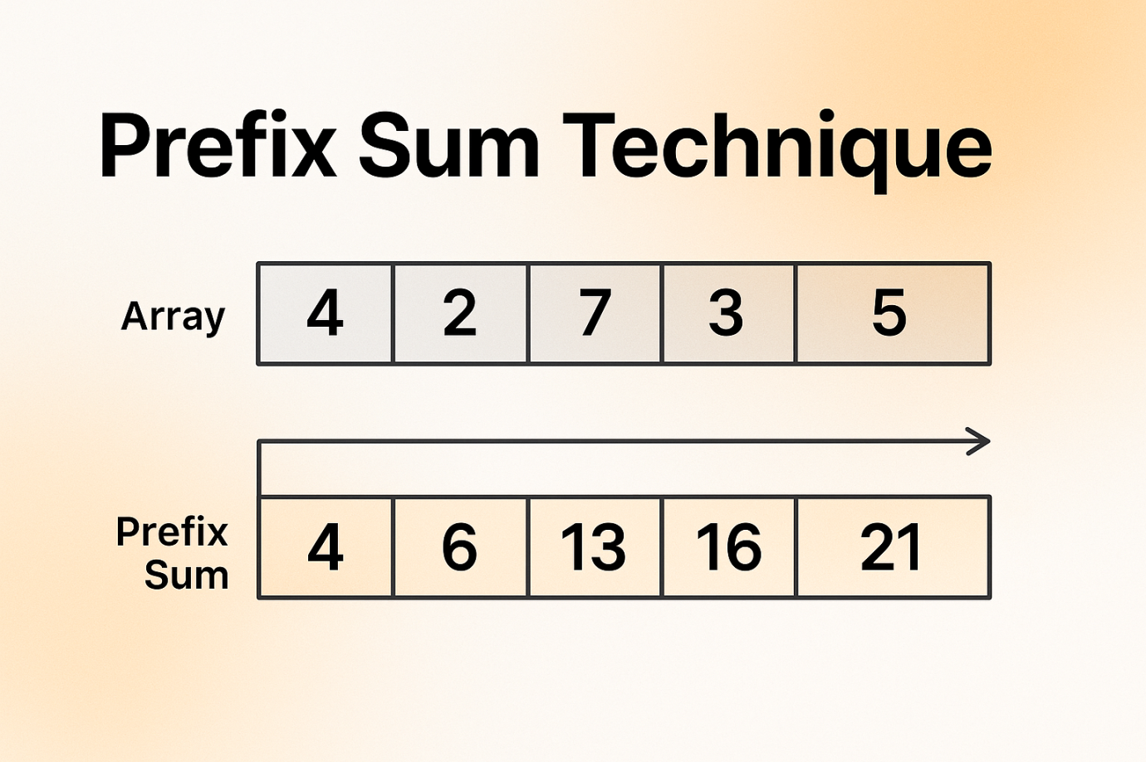

Understanding Prefix Sum
For an array A of n elements [a₁, a₂, a₃, ..., aₙ], the prefix sum array P of length n+1 is defined as:
- P[0] = 0 (an empty sum)
- P[i] = a₁ + a₂ + a₃ + ... + aᵢ for 1 ≤ i ≤ n
In mathematical notation, this can be expressed as:
P[i] = Σⱼ₌₁ᵏ A[j] where k = i

Basic Computation of Prefix Sum
Computing a prefix sum is straightforward. We iterate through the original array, keeping a running sum that we store at each position of our prefix sum array.

Example Computation
Let's look at a concrete example:
Original array: [3, 1, 4, 1, 5, 9, 2]
The prefix sum array would be:
- P[0] = 0 (empty sum)
- P[1] = 0 + 3 = 3
- P[2] = 3 + 1 = 4
- P[3] = 4 + 4 = 8
- P[4] = 8 + 1 = 9
- P[5] = 9 + 5 = 14
- P[6] = 14 + 9 = 23
- P[7] = 23 + 2 = 25
This gives us the prefix sum array: [0, 3, 4, 8, 9, 14, 23, 25]
With this prefix sum array, we can quickly find the sum of any contiguous subarray of the original array. For example, to find the sum of elements from index 2 to index 4 (1-indexed), we calculate P[6] - P[2] = 23 - 4 =19, which equals 4 + 1 + 5 + 9.
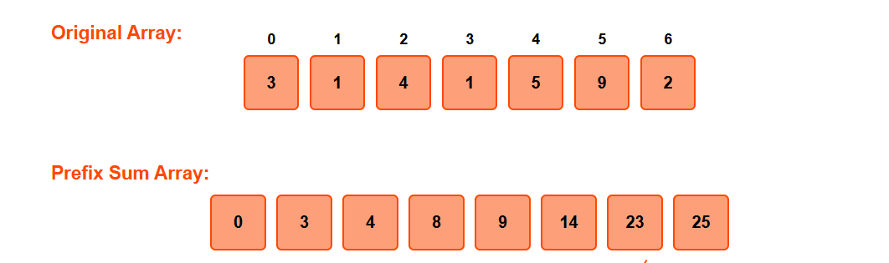

Construction of Prefix Sum Array

Step-by-Step Algorithm
Building a prefix sum array is straightforward:
- Initialize a prefix sum array P of length n+1 (where n is the length of the original array A)
- Set P[0] = 0
- For each index i from 1 to n:
- Compute P[i] = P[i-1] + A[i-1]
Note: The indexing might differ based on whether you're using 0-indexed or 1-indexed arrays. The above algorithm assumes the original array is 0-indexed.
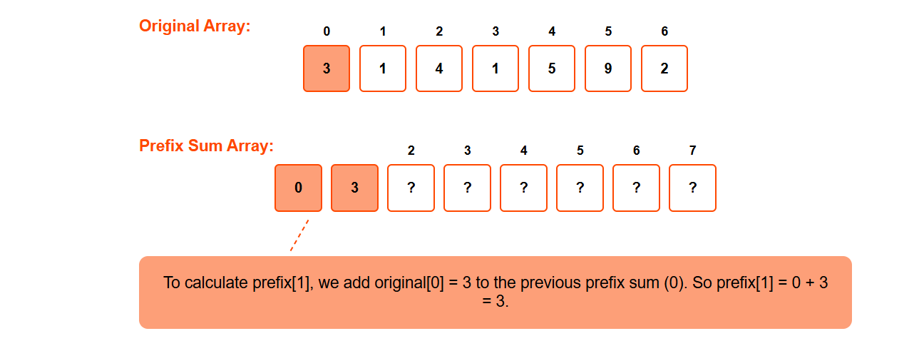
To calculate Prefix[1],we add original[0] = 3 to the previous sum(0).So prefix[1] = 0 +3 = 3
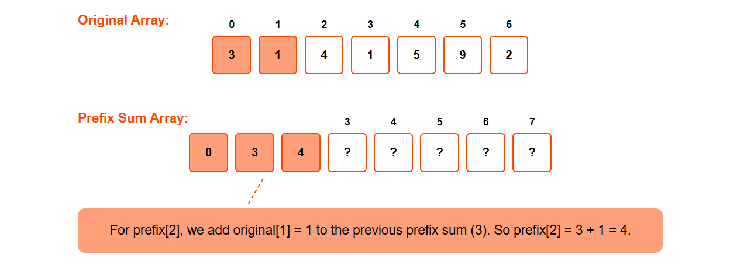
For Prefix[2],we add original[1] = 1 to the previous sum(3).So prefix[2] =3 +1=4.

Prefix Sum Visualization

Now, let's say we want the sum of elements in an array from index 2 to index 5. Using a normal for loop would take O(subarray size) time, since we need to iterate through each element in the range.
However, if we have a prefix sum array prepared, we can avoid iterating through each element. Since we already know the sum up to index 5, we can subtract the sum up to index 1. This effectively gives us the sum of the subarray from index 2 to 5.
So, General Formula Would Be
Sum(l,r)=prefix[r]−prefix[l−1]
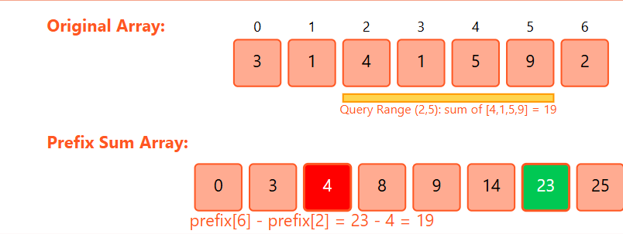

Time Complexity Analysis
The construction of a prefix sum array requires a single pass through the original array, making the time complexity O(n), where n is the size of the array. The space complexity is also O(n) for storing the prefix sum array.
This linear preprocessing time is acceptable because it enables constant-time range sum queries, which is a significant advantage in many applications.
import java.util.Stack;

public class SortStack {
public static void sortStack(Stack<Integer> stack) {
if (stack.isEmpty()) return;
int temp = stack.pop();
sortStack(stack);
insertSorted(stack, temp);
}

private static void insertSorted(Stack<Integer> stack, int element) {
if (stack.isEmpty() || element > stack.peek()) {
stack.push(element);
return;
}
int temp = stack.pop();
insertSorted(stack, element);
stack.push(temp);
}

public static void main(String[] args) {
Stack<Integer> stack = new Stack<>();
stack.push(34);
stack.push(3);
stack.push(31);
stack.push(98);
stack.push(92);
stack.push(23);

System.out.println("Original stack: " + stack);
sortStack(stack);
System.out.println("Sorted stack: " + stack);
}
}

